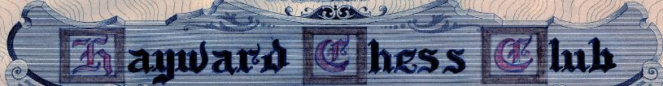
_______________________________________________________________________
Volume 1, Number 2 Cherryland Chess September 2016

The 1st club meeting on September 7th was quite a success. Over 20 players attended; among them were Fide Master Craig Mar, Life Master Frank Say, National Master Kerry Lawless, 9-year-old Expert Christopher Yoo, CalChess Journal Editor, Expert Frisco Del Rosario and 5-time club champion, Rahim Gran.

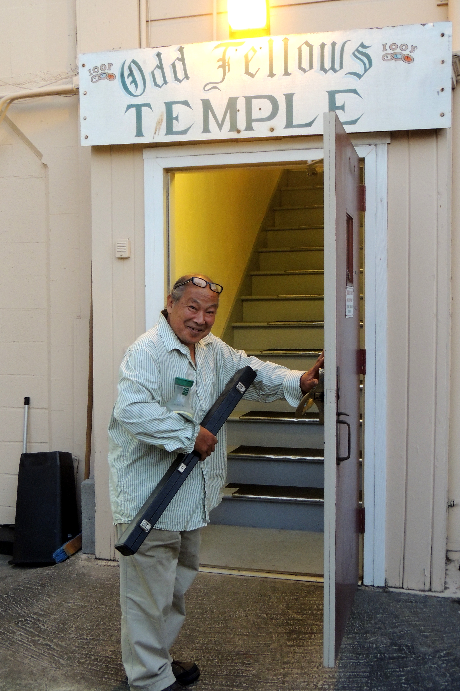
LM Frank Say opens the door for CalChess Photographer Richard Shorman

The 2nd club meeting, on September 14th, will feature an unrated speed chess tournament held under USCF rules. Entry fee will be $5, of which 60% will be returned as prizes. Registration will start at 7pm; games will begin at 7:30pm. PLEASE BRING CHESS CLOCKS!

